**WEEK – 2**

**PL-SQL**

**(Mandatory Hands-On Exercises)**

**Exercise 1: Control Structures**

**Scenario 1: Discount for customers above 60**

**Code:**

DECLARE

TYPE customer_type IS RECORD (

customer_id NUMBER,

age NUMBER,

loan_id NUMBER,

interest_rate NUMBER

);

TYPE customer_table IS TABLE OF customer_type INDEX BY BINARY_INTEGER;

v_customers customer_table;

v_discount_rate NUMBER := 1.0; -- 1% discount

BEGIN

v_customers(1).customer_id := 1;

v_customers(1).age := 65;

v_customers(1).loan_id := 101;

v_customers(1).interest_rate := 5.0;

v_customers(2).customer_id := 2;

v_customers(2).age := 55;

v_customers(2).loan_id := 102;

v_customers(2).interest_rate := 4.5;

v_customers(3).customer_id := 3;

v_customers(3).age := 70;

v_customers(3).loan_id := 103;

v_customers(3).interest_rate := 6.0;

FOR i IN 1..v_customers.COUNT LOOP

IF v_customers(i).age > 60 THEN

DBMS_OUTPUT.PUT_LINE('Customer ' || v_customers(i).customer_id ||

': Old rate ' || v_customers(i).interest_rate || '%');

v_customers(i).interest_rate := v_customers(i).interest_rate - v_discount_rate;

DBMS_OUTPUT.PUT_LINE('Applied discount. New rate: ' ||

v_customers(i).interest_rate || '%');

END IF;

END LOOP;

END;

/

**Output:**

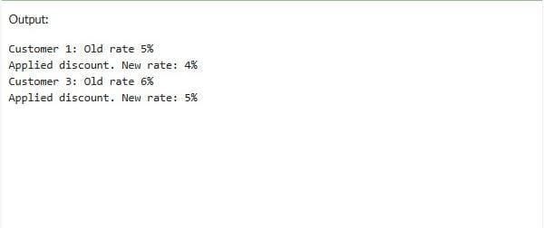

Scenario 2: VIP promotion based on balance:

Code:

DECLARE

TYPE customer_type IS RECORD (

customer_id NUMBER,

balance NUMBER,

is_vip VARCHAR2(5)

);

TYPE customer_table IS TABLE OF customer_type INDEX BY BINARY_INTEGER;

v_customers customer_table;

v_vip_threshold NUMBER := 10000;

BEGIN

v_customers(1).customer_id := 1;

v_customers(1).balance := 5000;

v_customers(1).is_vip := 'FALSE';

v_customers(2).customer_id := 2;

v_customers(2).balance := 15000;

v_customers(2).is_vip := 'FALSE';

v_customers(3).customer_id := 3;

v_customers(3).balance := 8000;

v_customers(3).is_vip := 'FALSE';

FOR i IN 1..v_customers.COUNT LOOP

IF v_customers(i).balance > v_vip_threshold THEN

v_customers(i).is_vip := 'TRUE';

DBMS_OUTPUT.PUT_LINE('Promoted customer ' || v_customers(i).customer_id ||

' to VIP (Balance: $' || v_customers(i).balance || ')');

END IF;

END LOOP;

END;

/

Output:

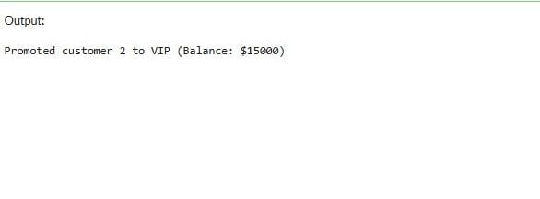

Scenario 3: Loan reminders

Code:

DECLARE

TYPE loan_type IS RECORD (

loan_id NUMBER,

due_date DATE,

customer_name VARCHAR2(100),

email VARCHAR2(100)

);

TYPE loan_table IS TABLE OF loan_type INDEX BY BINARY_INTEGER;

v_loans loan_table;

v_today DATE := SYSDATE;

BEGIN

v_loans(1).loan_id := 101;

v_loans(1).due_date := v_today + 15;

v_loans(1).customer_name := 'John Smith';

v_loans(1).email := 'john@example.com';

v_loans(2).loan_id := 102;

v_loans(2).due_date := v_today + 45;

v_loans(2).customer_name := 'Mary Johnson';

v_loans(2).email := 'mary@example.com';

v_loans(3).loan_id := 103;

v_loans(3).due_date := v_today + 10;

v_loans(3).customer_name := 'Robert Brown';

v_loans(3).email := 'robert@example.com';

DBMS_OUTPUT.PUT_LINE('Sending loan due reminders...');

DBMS_OUTPUT.PUT_LINE('----------------------------------');

FOR i IN 1..v_loans.COUNT LOOP

IF v_loans(i).due_date BETWEEN v_today AND v_today + 30 THEN

DBMS_OUTPUT.PUT_LINE('Dear ' || v_loans(i).customer_name || ',');

DBMS_OUTPUT.PUT_LINE('Your loan (ID: ' || v_loans(i).loan_id || ') is due in ' ||

(v_loans(i).due_date - v_today) || ' days.');

DBMS_OUTPUT.PUT_LINE('Email: ' || v_loans(i).email);

DBMS_OUTPUT.PUT_LINE('----------------------------------');

END IF;

END LOOP;

END;

/

Output:

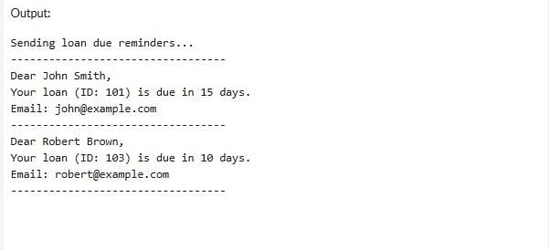

**Exercise 3: Stored Procedures**

**Scenario 1: The bank needs to process monthly interest for all savings accounts.**

Code :

-- Drop and create Accounts table

BEGIN

EXECUTE IMMEDIATE 'DROP TABLE Accounts';

EXCEPTION

WHEN OTHERS THEN NULL;

END;

/

CREATE TABLE Accounts (

AccountID NUMBER PRIMARY KEY,

AccountType VARCHAR2(20),

Balance NUMBER(10,2)

);

INSERT INTO Accounts VALUES (1, 'Savings', 1000.00);

INSERT INTO Accounts VALUES (2, 'Savings', 2000.00);

INSERT INTO Accounts VALUES (3, 'Checking', 3000.00);

COMMIT;

CREATE OR REPLACE PROCEDURE ProcessMonthlyInterest IS

BEGIN

UPDATE Accounts

SET Balance = Balance * 1.01

WHERE AccountType = 'Savings';

END;

/

BEGIN

ProcessMonthlyInterest;

END;

/

SELECT * FROM Accounts;

Output:

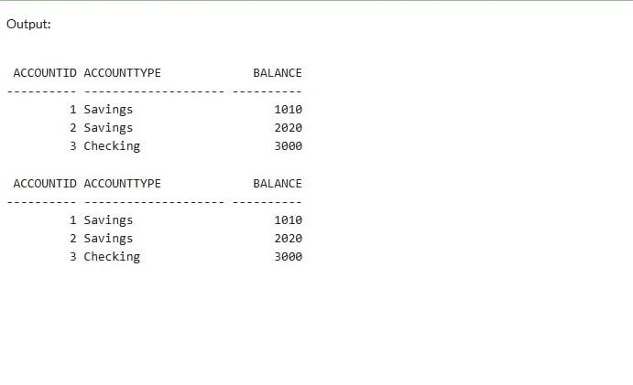

**Scenario 2: The bank wants to implement a bonus scheme for employees based on their performance.**

Code:

-- Drop and create Employees table

BEGIN

EXECUTE IMMEDIATE 'DROP TABLE Employees';

EXCEPTION

WHEN OTHERS THEN NULL;

END;

/

CREATE TABLE Employees (

EmpID NUMBER PRIMARY KEY,

Name VARCHAR2(50),

Department VARCHAR2(50),

Salary NUMBER(10,2)

);

INSERT INTO Employees VALUES (1, 'Alice', 'HR', 50000.00);

INSERT INTO Employees VALUES (2, 'Bob', 'IT', 60000.00);

INSERT INTO Employees VALUES (3, 'Charlie', 'IT', 70000.00);

COMMIT;

CREATE OR REPLACE PROCEDURE UpdateEmployeeBonus (

dept IN VARCHAR2,

bonusPercent IN NUMBER

) IS

BEGIN

UPDATE Employees

SET Salary = Salary + (Salary * bonusPercent / 100)

WHERE Department = dept;

END;

/

BEGIN

UpdateEmployeeBonus('IT', 10);

END;

/

SELECT * FROM Employees;

Output:

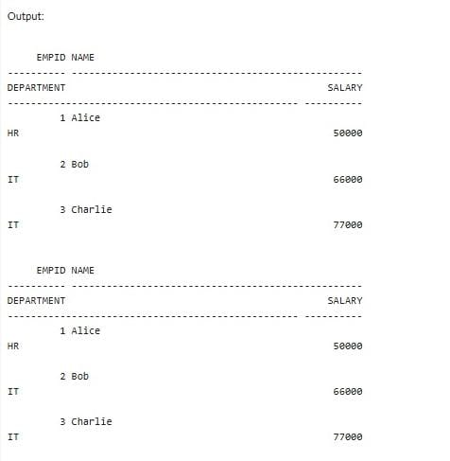

**Scenario 3: Customers should be able to transfer funds between their accounts.**

Code:

BEGIN

EXECUTE IMMEDIATE 'DROP TABLE BankAccounts';

EXCEPTION

WHEN OTHERS THEN NULL;

END;

/

CREATE TABLE BankAccounts (

AccountNumber NUMBER PRIMARY KEY,

CustomerName VARCHAR2(50),

Balance NUMBER(10,2)

);

INSERT INTO BankAccounts VALUES (101, 'John Doe', 5000.00);

INSERT INTO BankAccounts VALUES (102, 'Jane Smith', 3000.00);

COMMIT;

CREATE OR REPLACE PROCEDURE TransferFunds (

sourceAcc IN NUMBER,

destAcc IN NUMBER,

amount IN NUMBER

) IS

sourceBalance NUMBER;

BEGIN

SELECT Balance INTO sourceBalance

FROM BankAccounts

WHERE AccountNumber = sourceAcc;

IF sourceBalance >= amount THEN

UPDATE BankAccounts

SET Balance = Balance - amount

WHERE AccountNumber = sourceAcc;

UPDATE BankAccounts

SET Balance = Balance + amount

WHERE AccountNumber = destAcc;

ELSE

RAISE_APPLICATION_ERROR(-20001, 'Insufficient funds');

END IF;

END;

/

BEGIN

TransferFunds(101, 102, 1000);

END;

/

SELECT * FROM BankAccounts;

Output:

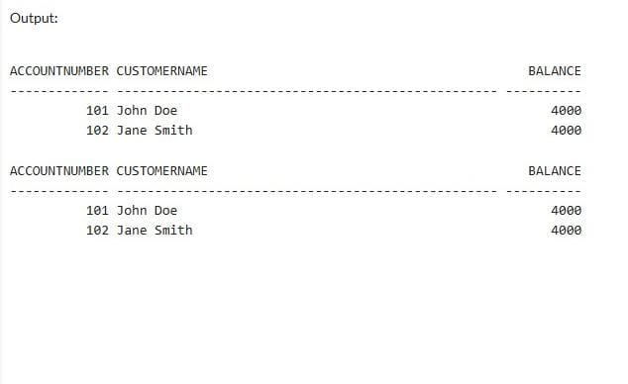

**(Non – Mandatory exercises)**

**Exercise 2: Error Handling**

**Scenario 1: Handle exceptions during fund transfers between accounts.**

Code :

BEGIN

EXECUTE IMMEDIATE 'DROP TABLE BankAccounts';

EXCEPTION

WHEN OTHERS THEN NULL;

END;

/

CREATE TABLE BankAccounts (

AccountID NUMBER PRIMARY KEY,

Balance NUMBER

);

INSERT INTO BankAccounts VALUES (1, 5000);

INSERT INTO BankAccounts VALUES (2, 2000);

COMMIT;

CREATE OR REPLACE PROCEDURE SafeTransferFunds (

fromAcc IN NUMBER,

toAcc IN NUMBER,

amt IN NUMBER

) IS

BEGIN

DECLARE

curr_balance NUMBER;

BEGIN

SELECT Balance INTO curr_balance FROM BankAccounts WHERE AccountID = fromAcc;

IF curr_balance < amt THEN

RAISE_APPLICATION_ERROR(-20001, 'Insufficient funds');

END IF;

UPDATE BankAccounts SET Balance = Balance - amt WHERE AccountID = fromAcc;

UPDATE BankAccounts SET Balance = Balance + amt WHERE AccountID = toAcc;

COMMIT;

DBMS_OUTPUT.PUT_LINE('Transfer successful');

EXCEPTION

WHEN OTHERS THEN

ROLLBACK;

DBMS_OUTPUT.PUT_LINE('Transfer failed: ' || SQLERRM);

END;

END;

/

BEGIN

SafeTransferFunds(1, 2, 1000);

SafeTransferFunds(1, 2, 10000);

END;

/

Output:

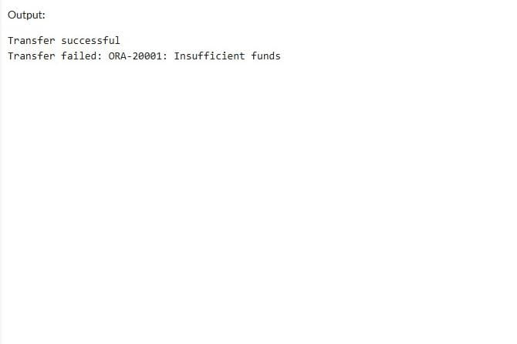

**Scenario 2: Manage errors when updating employee salaries.**

Code:

BEGIN

EXECUTE IMMEDIATE 'DROP TABLE Employees';

EXCEPTION

WHEN OTHERS THEN NULL;

END;

/

CREATE TABLE Employees (

EmpID NUMBER PRIMARY KEY,

Name VARCHAR2(100),

Salary NUMBER

);

INSERT INTO Employees VALUES (101, 'Alice', 30000);

INSERT INTO Employees VALUES (102, 'Bob', 40000);

COMMIT;

CREATE OR REPLACE PROCEDURE UpdateSalary (

emp_id IN NUMBER,

percent IN NUMBER

) IS

BEGIN

UPDATE Employees

SET Salary = Salary + (Salary * percent / 100)

WHERE EmpID = emp_id;

IF SQL%ROWCOUNT = 0 THEN

RAISE_APPLICATION_ERROR(-20002, 'Employee ID not found');

END IF;

COMMIT;

DBMS_OUTPUT.PUT_LINE('Salary updated successfully');

EXCEPTION

WHEN OTHERS THEN

ROLLBACK;

DBMS_OUTPUT.PUT_LINE('Update failed: ' || SQLERRM);

END;

/

BEGIN

UpdateSalary(101, 10);

UpdateSalary(999, 5);

END;

/

Output:

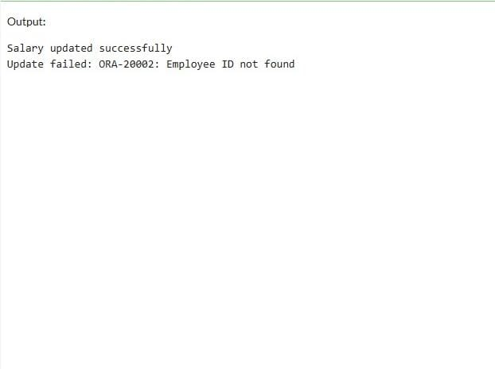

**Scenario 3: Ensure data integrity when adding a new customer.**

Code:

BEGIN

EXECUTE IMMEDIATE 'DROP TABLE Customers';

EXCEPTION

WHEN OTHERS THEN NULL;

END;

/

CREATE TABLE Customers (

CustomerID NUMBER PRIMARY KEY,

Name VARCHAR2(100)

);

INSERT INTO Customers VALUES (1, 'Ram');

COMMIT;

CREATE OR REPLACE PROCEDURE AddNewCustomer (

cid IN NUMBER,

cname IN VARCHAR2

) IS

BEGIN

INSERT INTO Customers VALUES (cid, cname);

COMMIT;

DBMS_OUTPUT.PUT_LINE('Customer added successfully');

EXCEPTION

WHEN DUP_VAL_ON_INDEX THEN

DBMS_OUTPUT.PUT_LINE('Error: Customer with ID ' || cid || ' already exists.');

WHEN OTHERS THEN

DBMS_OUTPUT.PUT_LINE('Insertion failed: ' || SQLERRM);

END;

/

BEGIN

AddNewCustomer(2, 'Krishna');

AddNewCustomer(1, 'Duplicate');

END;

/

Output:

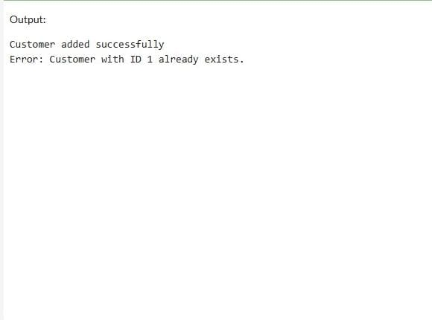

**Exercise 7: Packages**

**Scenario 1: Group all customer-related procedures and functions into a package.**

**Scenario 2: Create a package to manage employee data.**

**Scenario 3: Group all account-related operations into a package.**

Code:

BEGIN

EXECUTE IMMEDIATE 'DROP TABLE Transactions';

EXECUTE IMMEDIATE 'DROP TABLE Accounts';

EXECUTE IMMEDIATE 'DROP TABLE Loans';

EXECUTE IMMEDIATE 'DROP TABLE Customers';

EXECUTE IMMEDIATE 'DROP TABLE Employees';

EXCEPTION

WHEN OTHERS THEN NULL;

END;

/

CREATE TABLE Customers (

CustomerID NUMBER PRIMARY KEY,

Name VARCHAR2(100),

DOB DATE,

Balance NUMBER,

LastModified DATE

);

CREATE TABLE Accounts (

AccountID NUMBER PRIMARY KEY,

CustomerID NUMBER,

AccountType VARCHAR2(20),

Balance NUMBER,

LastModified DATE,

FOREIGN KEY (CustomerID) REFERENCES Customers(CustomerID)

);

CREATE TABLE Transactions (

TransactionID NUMBER PRIMARY KEY,

AccountID NUMBER,

TransactionDate DATE,

Amount NUMBER,

TransactionType VARCHAR2(10),

FOREIGN KEY (AccountID) REFERENCES Accounts(AccountID)

);

CREATE TABLE Loans (

LoanID NUMBER PRIMARY KEY,

CustomerID NUMBER,

LoanAmount NUMBER,

InterestRate NUMBER,

StartDate DATE,

EndDate DATE,

FOREIGN KEY (CustomerID) REFERENCES Customers(CustomerID)

);

CREATE TABLE Employees (

EmployeeID NUMBER PRIMARY KEY,

Name VARCHAR2(100),

Position VARCHAR2(50),

Salary NUMBER,

Department VARCHAR2(50),

HireDate DATE

);

INSERT INTO Customers VALUES (1, 'John Doe', TO_DATE('1985-05-15', 'YYYY-MM-DD'), 1000, SYSDATE);

INSERT INTO Customers VALUES (2, 'Jane Smith', TO_DATE('1990-07-20', 'YYYY-MM-DD'), 1500, SYSDATE);

INSERT INTO Accounts VALUES (1, 1, 'Savings', 1000, SYSDATE);

INSERT INTO Accounts VALUES (2, 2, 'Checking', 1500, SYSDATE);

INSERT INTO Employees VALUES (1, 'Alice Johnson', 'Manager', 70000, 'HR', TO_DATE('2015-06-15', 'YYYY-MM-DD'));

INSERT INTO Employees VALUES (2, 'Bob Brown', 'Developer', 60000, 'IT', TO_DATE('2017-03-20', 'YYYY-MM-DD'));

CREATE OR REPLACE PACKAGE CustomerManagement IS

PROCEDURE AddCustomer(custID IN NUMBER, name IN VARCHAR2, dob IN DATE, balance IN NUMBER);

PROCEDURE UpdateCustomer(custID IN NUMBER, name IN VARCHAR2, dob IN DATE);

FUNCTION GetCustomerBalance(custID IN NUMBER) RETURN NUMBER;

END CustomerManagement;

/

CREATE OR REPLACE PACKAGE BODY CustomerManagement IS

PROCEDURE AddCustomer(custID IN NUMBER, name IN VARCHAR2, dob IN DATE, balance IN NUMBER) IS

BEGIN

INSERT INTO Customers VALUES (custID, name, dob, balance, SYSDATE);

COMMIT;

EXCEPTION

WHEN DUP_VAL_ON_INDEX THEN

DBMS_OUTPUT.PUT_LINE('Customer already exists');

END;

PROCEDURE UpdateCustomer(custID IN NUMBER, name IN VARCHAR2, dob IN DATE) IS

BEGIN

UPDATE Customers SET Name = name, DOB = dob, LastModified = SYSDATE

WHERE CustomerID = custID;

IF SQL%ROWCOUNT = 0 THEN

DBMS_OUTPUT.PUT_LINE('Customer not found');

ELSE

COMMIT;

END IF;

END;

FUNCTION GetCustomerBalance(custID IN NUMBER) RETURN NUMBER IS

bal NUMBER;

BEGIN

SELECT Balance INTO bal FROM Customers WHERE CustomerID = custID;

RETURN bal;

EXCEPTION

WHEN NO_DATA_FOUND THEN

RETURN NULL;

END;

END CustomerManagement;

/

CREATE OR REPLACE PACKAGE EmployeeManagement IS

PROCEDURE HireEmployee(empID IN NUMBER, name IN VARCHAR2, position IN VARCHAR2,

salary IN NUMBER, dept IN VARCHAR2, hireDate IN DATE);

PROCEDURE UpdateEmployee(empID IN NUMBER, position IN VARCHAR2, salary IN NUMBER);

FUNCTION AnnualSalary(empID IN NUMBER) RETURN NUMBER;

END EmployeeManagement;

/

CREATE OR REPLACE PACKAGE BODY EmployeeManagement IS

PROCEDURE HireEmployee(empID IN NUMBER, name IN VARCHAR2, position IN VARCHAR2,

salary IN NUMBER, dept IN VARCHAR2, hireDate IN DATE) IS

BEGIN

INSERT INTO Employees VALUES (empID, name, position, salary, dept, hireDate);

COMMIT;

EXCEPTION

WHEN DUP_VAL_ON_INDEX THEN

DBMS_OUTPUT.PUT_LINE('Employee already exists');

END;

PROCEDURE UpdateEmployee(empID IN NUMBER, position IN VARCHAR2, salary IN NUMBER) IS

BEGIN

UPDATE Employees SET Position = position, Salary = salary WHERE EmployeeID = empID;

IF SQL%ROWCOUNT = 0 THEN

DBMS_OUTPUT.PUT_LINE('Employee not found');

ELSE

COMMIT;

END IF;

END;

FUNCTION AnnualSalary(empID IN NUMBER) RETURN NUMBER IS

monthly NUMBER;

BEGIN

SELECT Salary INTO monthly FROM Employees WHERE EmployeeID = empID;

RETURN monthly * 12;

EXCEPTION

WHEN NO_DATA_FOUND THEN

RETURN NULL;

END;

END EmployeeManagement;

/

CREATE OR REPLACE PACKAGE AccountOperations IS

PROCEDURE OpenAccount(accID IN NUMBER, custID IN NUMBER, accType IN VARCHAR2, balance IN NUMBER);

PROCEDURE CloseAccount(accID IN NUMBER);

FUNCTION GetTotalBalance(custID IN NUMBER) RETURN NUMBER;

END AccountOperations;

/

CREATE OR REPLACE PACKAGE BODY AccountOperations IS

PROCEDURE OpenAccount(accID IN NUMBER, custID IN NUMBER, accType IN VARCHAR2, balance IN NUMBER) IS

BEGIN

INSERT INTO Accounts VALUES (accID, custID, accType, balance, SYSDATE);

COMMIT;

EXCEPTION

WHEN DUP_VAL_ON_INDEX THEN

DBMS_OUTPUT.PUT_LINE('Account already exists');

END;

PROCEDURE CloseAccount(accID IN NUMBER) IS

BEGIN

DELETE FROM Accounts WHERE AccountID = accID;

IF SQL%ROWCOUNT = 0 THEN

DBMS_OUTPUT.PUT_LINE('Account not found');

ELSE

COMMIT;

END IF;

END;

FUNCTION GetTotalBalance(custID IN NUMBER) RETURN NUMBER IS

total NUMBER;

BEGIN

SELECT SUM(Balance) INTO total FROM Accounts WHERE CustomerID = custID;

RETURN total;

EXCEPTION

WHEN NO_DATA_FOUND THEN

RETURN 0;

END;

END AccountOperations;

/

BEGIN

CustomerManagement.AddCustomer(3, 'Ravi', TO_DATE('1992-11-11', 'YYYY-MM-DD'), 2500);

EmployeeManagement.HireEmployee(3, 'Charlie', 'Analyst', 50000, 'Finance', SYSDATE);

AccountOperations.OpenAccount(3, 3, 'Savings', 2500);

DBMS_OUTPUT.PUT_LINE('Customer Balance: ' || CustomerManagement.GetCustomerBalance(3));

DBMS_OUTPUT.PUT_LINE('Annual Salary: ' || EmployeeManagement.AnnualSalary(3));

DBMS_OUTPUT.PUT_LINE('Total Account Balance: ' || AccountOperations.GetTotalBalance(3));

END;

/

Output:

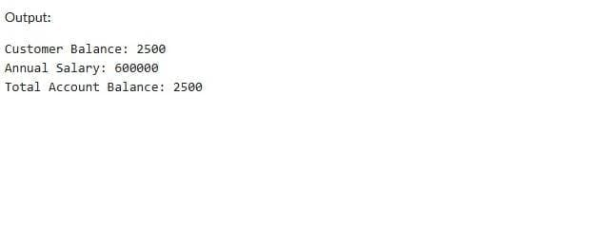

**Exercise 4: Functions**

**Scenario 1: Calculate the age of customers for eligibility checks.**

**Scenario 2: The bank needs to compute the monthly installment for a loan.**

**Scenario 3: Check if a customer has sufficient balance before making a transaction.**

Code:

-- Enable DBMS Output

SET SERVEROUTPUT ON;

-------------------------------

-- Scenario 1: CalculateAge

-------------------------------

CREATE OR REPLACE FUNCTION CalculateAge(dob DATE)

RETURN NUMBER

IS

age NUMBER;

BEGIN

age := FLOOR(MONTHS_BETWEEN(SYSDATE, dob)/12);

RETURN age;

END;

/

-- Test Scenario 1

BEGIN

DBMS_OUTPUT.PUT_LINE('Scenario 1 - Age is: ' || CalculateAge(DATE '1990-06-15'));

END;

/

-------------------------------

-- Scenario 2: CalculateMonthlyInstallment

-------------------------------

CREATE OR REPLACE FUNCTION CalculateMonthlyInstallment(

loan_amount NUMBER,

annual_interest_rate NUMBER,

duration_years NUMBER

)

RETURN NUMBER

IS

monthly_interest_rate NUMBER;

months NUMBER;

installment NUMBER;

BEGIN

monthly_interest_rate := annual_interest_rate / 12 / 100;

months := duration_years * 12;

IF monthly_interest_rate = 0 THEN

installment := loan_amount / months;

ELSE

installment := loan_amount * monthly_interest_rate /

(1 - POWER(1 + monthly_interest_rate, -months));

END IF;

RETURN ROUND(installment, 2);

END;

/

-- Test Scenario 2

BEGIN

DBMS_OUTPUT.PUT_LINE('Scenario 2 - Monthly Installment: ' ||

CalculateMonthlyInstallment(100000, 10, 5));

END;

/

-------------------------------

-- Scenario 3: HasSufficientBalance

-------------------------------

-- Create a sample table

BEGIN

EXECUTE IMMEDIATE 'DROP TABLE Accounts';

EXCEPTION

WHEN OTHERS THEN NULL;

END;

/

CREATE TABLE Accounts (

account_id NUMBER PRIMARY KEY,

balance NUMBER

);

-- Insert test data

INSERT INTO Accounts VALUES (101, 5000);

INSERT INTO Accounts VALUES (102, 15000);

COMMIT;

-- Create Function

CREATE OR REPLACE FUNCTION HasSufficientBalance(p_account_id NUMBER, p_amount NUMBER)

RETURN BOOLEAN

IS

acc_balance NUMBER;

BEGIN

SELECT balance INTO acc_balance FROM Accounts WHERE account_id = p_account_id;

IF acc_balance >= p_amount THEN

RETURN TRUE;

ELSE

RETURN FALSE;

END IF;

EXCEPTION

WHEN NO_DATA_FOUND THEN

RETURN FALSE;

END;

/

-- Test Scenario 3

DECLARE

result BOOLEAN;

BEGIN

result := HasSufficientBalance(101, 3000);

IF result THEN

DBMS_OUTPUT.PUT_LINE('Scenario 3 - Sufficient Balance');

ELSE

DBMS_OUTPUT.PUT_LINE('Scenario 3 - Insufficient Balance');

END IF;

END;

/

Output:

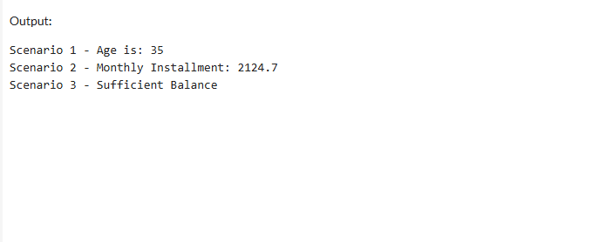

**Exercise 5: Triggers**

**Scenario 1: Automatically update the last modified date when a customer's record is updated.**

**Scenario 2: Maintain an audit log for all transactions.**

**Scenario 3: Enforce business rules on deposits and withdrawals.**

Code:

SET SERVEROUTPUT ON;

----------------------------------------------------------

-- Scenario 1: UpdateCustomerLastModified Trigger

----------------------------------------------------------

BEGIN

EXECUTE IMMEDIATE 'DROP TABLE Customers';

EXCEPTION WHEN OTHERS THEN NULL;

END;

/

CREATE TABLE Customers (

customer_id NUMBER PRIMARY KEY,

name VARCHAR2(50),

email VARCHAR2(50),

last_modified DATE

);

INSERT INTO Customers VALUES (1, 'Ravi', 'ravi@example.com', SYSDATE);

COMMIT;

CREATE OR REPLACE TRIGGER UpdateCustomerLastModified

BEFORE UPDATE ON Customers

FOR EACH ROW

BEGIN

:NEW.last_modified := SYSDATE;

END;

/

BEGIN

UPDATE Customers SET email = 'ravi.updated@example.com' WHERE customer_id = 1;

COMMIT;

DBMS_OUTPUT.PUT_LINE('Scenario 1 - Last Modified:');

FOR c IN (SELECT * FROM Customers) LOOP

DBMS_OUTPUT.PUT_LINE('Customer: ' || c.name || ', Last Modified: ' || TO_CHAR(c.last_modified, 'DD-Mon-YYYY HH24:MI'));

END LOOP;

END;

/

----------------------------------------------------------

-- Scenario 2: LogTransaction Trigger + AuditLog

----------------------------------------------------------

BEGIN

EXECUTE IMMEDIATE 'DROP TABLE Transactions_Log';

EXECUTE IMMEDIATE 'DROP TABLE AuditLog';

EXCEPTION WHEN OTHERS THEN NULL;

END;

/

CREATE TABLE Transactions_Log (

txn_id NUMBER PRIMARY KEY,

account_id NUMBER,

txn_type VARCHAR2(10),

amount NUMBER

);

CREATE TABLE AuditLog (

audit_id NUMBER GENERATED ALWAYS AS IDENTITY PRIMARY KEY,

txn_id NUMBER,

action_date DATE,

message VARCHAR2(100)

);

CREATE OR REPLACE TRIGGER LogTransaction

AFTER INSERT ON Transactions_Log

FOR EACH ROW

BEGIN

INSERT INTO AuditLog (txn_id, action_date, message)

VALUES (:NEW.txn_id, SYSDATE, 'Transaction inserted of type: ' || :NEW.txn_type);

END;

/

INSERT INTO Transactions_Log VALUES (1001, 101, 'Deposit', 3000);

COMMIT;

BEGIN

DBMS_OUTPUT.PUT_LINE(CHR(10) || 'Scenario 2 - Audit Log:');

FOR r IN (SELECT * FROM AuditLog) LOOP

DBMS_OUTPUT.PUT_LINE('Txn ID: ' || r.txn_id || ', Message: ' || r.message);

END LOOP;

END;

/

----------------------------------------------------------

-- Scenario 3: CheckTransactionRules Trigger

----------------------------------------------------------

BEGIN

EXECUTE IMMEDIATE 'DROP TABLE Transactions_Business';

EXECUTE IMMEDIATE 'DROP TABLE Accounts';

EXCEPTION WHEN OTHERS THEN NULL;

END;

/

CREATE TABLE Accounts (

account_id NUMBER PRIMARY KEY,

balance NUMBER

);

CREATE TABLE Transactions_Business (

txn_id NUMBER PRIMARY KEY,

account_id NUMBER,

txn_type VARCHAR2(10),

amount NUMBER

);

INSERT INTO Accounts VALUES (101, 5000);

COMMIT;

CREATE OR REPLACE TRIGGER CheckTransactionRules

BEFORE INSERT ON Transactions_Business

FOR EACH ROW

DECLARE

acc_balance NUMBER;

BEGIN

SELECT balance INTO acc_balance FROM Accounts WHERE account_id = :NEW.account_id;

IF :NEW.txn_type = 'Withdrawal' AND :NEW.amount > acc_balance THEN

RAISE_APPLICATION_ERROR(-20001, 'Withdrawal exceeds account balance.');

ELSIF :NEW.txn_type = 'Deposit' AND :NEW.amount <= 0 THEN

RAISE_APPLICATION_ERROR(-20002, 'Deposit must be positive.');

END IF;

END;

/

INSERT INTO Transactions_Business VALUES (2001, 101, 'Withdrawal', 1000);

INSERT INTO Transactions_Business VALUES (2002, 101, 'Deposit', 3000);

BEGIN

INSERT INTO Transactions_Business VALUES (2003, 101, 'Withdrawal', 10000);

EXCEPTION

WHEN OTHERS THEN

DBMS_OUTPUT.PUT_LINE(CHR(10) || 'Scenario 3 - Error: ' || SUBSTR(SQLERRM, INSTR(SQLERRM, ':') + 2));

END;

/

BEGIN

INSERT INTO Transactions_Business VALUES (2004, 101, 'Deposit', -500);

EXCEPTION

WHEN OTHERS THEN

DBMS_OUTPUT.PUT_LINE('Scenario 3 - Error: ' || SUBSTR(SQLERRM, INSTR(SQLERRM, ':') + 2));

END;

/

Output:

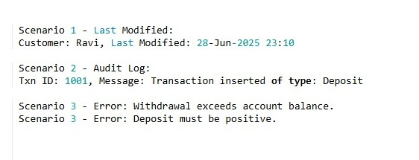

**Exercise 6: Cursors**

**Scenario 1: Generate monthly statements for all customers.**

**Scenario 2: Apply annual fee to all accounts.**

**Scenario 3: Update the interest rate for all loans based on a new policy.**

Code:

SET SERVEROUTPUT ON;

------------------------------------------------------------

-- Scenario 1: GenerateMonthlyStatements (Explicit Cursor)

------------------------------------------------------------

BEGIN

EXECUTE IMMEDIATE 'DROP TABLE Transactions';

EXECUTE IMMEDIATE 'DROP TABLE Customers';

EXCEPTION WHEN OTHERS THEN NULL;

END;

/

CREATE TABLE Customers (

customer_id NUMBER PRIMARY KEY,

name VARCHAR2(50)

);

CREATE TABLE Transactions (

txn_id NUMBER PRIMARY KEY,

customer_id NUMBER,

txn_date DATE,

txn_type VARCHAR2(10),

amount NUMBER

);

INSERT INTO Customers VALUES (1, 'Ravi');

INSERT INTO Customers VALUES (2, 'Priya');

INSERT INTO Transactions VALUES (1001, 1, SYSDATE, 'Deposit', 5000);

INSERT INTO Transactions VALUES (1002, 1, SYSDATE, 'Withdrawal', 2000);

INSERT INTO Transactions VALUES (1003, 2, ADD_MONTHS(SYSDATE, -1), 'Deposit', 3000);

INSERT INTO Transactions VALUES (1004, 2, SYSDATE, 'Deposit', 4000);

COMMIT;

-- Cursor block

DECLARE

CURSOR txn_cursor IS

SELECT c.name, t.txn_date, t.txn_type, t.amount

FROM Customers c

JOIN Transactions t ON c.customer_id = t.customer_id

WHERE TO_CHAR(t.txn_date, 'MMYYYY') = TO_CHAR(SYSDATE, 'MMYYYY');

v_name Customers.name%TYPE;

v_date DATE;

v_type VARCHAR2(10);

v_amount NUMBER;

BEGIN

DBMS_OUTPUT.PUT_LINE('Scenario 1 - Monthly Statements:');

OPEN txn_cursor;

LOOP

FETCH txn_cursor INTO v_name, v_date, v_type, v_amount;

EXIT WHEN txn_cursor%NOTFOUND;

DBMS_OUTPUT.PUT_LINE('Customer: ' || v_name || ', Date: ' || TO_CHAR(v_date, 'DD-Mon-YYYY') ||

', Type: ' || v_type || ', Amount: ' || v_amount);

END LOOP;

CLOSE txn_cursor;

END;

/

------------------------------------------------------------

-- Scenario 2: ApplyAnnualFee (Explicit Cursor)

------------------------------------------------------------

BEGIN

EXECUTE IMMEDIATE 'DROP TABLE Accounts';

EXCEPTION WHEN OTHERS THEN NULL;

END;

/

CREATE TABLE Accounts (

account_id NUMBER PRIMARY KEY,

balance NUMBER

);

INSERT INTO Accounts VALUES (101, 7000);

INSERT INTO Accounts VALUES (102, 15000);

COMMIT;

DECLARE

CURSOR acc_cursor IS

SELECT account_id, balance FROM Accounts;

v_acc_id Accounts.account_id%TYPE;

v_balance Accounts.balance%TYPE;

v_fee CONSTANT NUMBER := 250;

BEGIN

DBMS_OUTPUT.PUT_LINE(CHR(10) || 'Scenario 2 - Applying Annual Fee:');

OPEN acc_cursor;

LOOP

FETCH acc_cursor INTO v_acc_id, v_balance;

EXIT WHEN acc_cursor%NOTFOUND;

UPDATE Accounts

SET balance = balance - v_fee

WHERE account_id = v_acc_id;

DBMS_OUTPUT.PUT_LINE('Account ID: ' || v_acc_id || ', Fee Deducted: ' || v_fee);

END LOOP;

CLOSE acc_cursor;

COMMIT;

END;

/

------------------------------------------------------------

-- Scenario 3: UpdateLoanInterestRates (Explicit Cursor)

------------------------------------------------------------

BEGIN

EXECUTE IMMEDIATE 'DROP TABLE Loans';

EXCEPTION WHEN OTHERS THEN NULL;

END;

/

CREATE TABLE Loans (

loan_id NUMBER PRIMARY KEY,

customer_id NUMBER,

interest_rate NUMBER

);

INSERT INTO Loans VALUES (301, 1, 8.5);

INSERT INTO Loans VALUES (302, 2, 9.5);

COMMIT;

DECLARE

CURSOR loan_cursor IS

SELECT loan_id, interest_rate FROM Loans;

v_loan_id Loans.loan_id%TYPE;

v_old_rate Loans.interest_rate%TYPE;

v_new_rate NUMBER;

BEGIN

DBMS_OUTPUT.PUT_LINE(CHR(10) || 'Scenario 3 - Updating Loan Interest Rates:');

OPEN loan_cursor;

LOOP

FETCH loan_cursor INTO v_loan_id, v_old_rate;

EXIT WHEN loan_cursor%NOTFOUND;

-- Policy: If interest >= 9%, reduce by 0.5%

IF v_old_rate >= 9 THEN

v_new_rate := v_old_rate - 0.5;

ELSE

v_new_rate := v_old_rate;

END IF;

UPDATE Loans

SET interest_rate = v_new_rate

WHERE loan_id = v_loan_id;

DBMS_OUTPUT.PUT_LINE('Loan ID: ' || v_loan_id || ', Old Rate: ' || v_old_rate ||

', New Rate: ' || v_new_rate);

END LOOP;

CLOSE loan_cursor;

COMMIT;

END;

/

Output:

